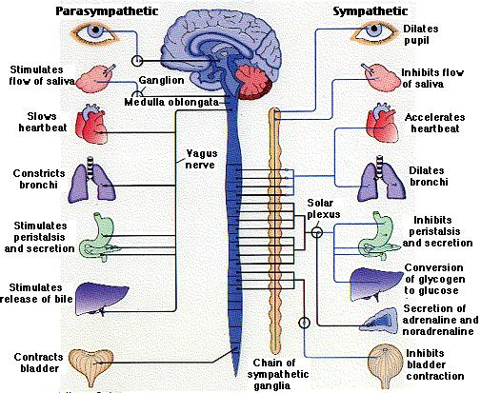
Parasympathetic and Sympathetic Nervous Systems

