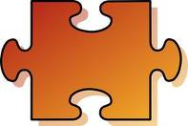

**Life Problems**

**Exercise Faith**

**Grounding Events**

**Listen to Music**

**Good Night Sleep**

**Good Choices**

**Think of Blessings Pray**

**Default to New Problems**

**Make Bad Choices**

**Drink or Use Drugs**

**Violence and Anger**

**Bring up Unresolved Issues**

**A baby needs help to put**

**together the pieces and define**

**its strengths and weaknesses**

**A baby has the pieces of what**

**it needs to define itself**

Relationships

Assets



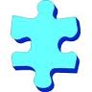

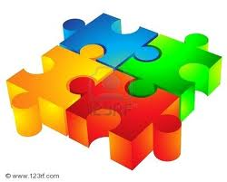



**Defining the Self**

**Defends Self**

**Ego**

**I**

Fall Apart

Go to Pieces

Despair

Suicide